Want to try dessert Yoga? ☺
Yoga
with Scott MacLeod
Imaginative Freeing Easing Integrative
http://scottmacleod.com/yoga.htm
412 478 0116 – scott@scottmacleod.com
Call to reserve your place today!

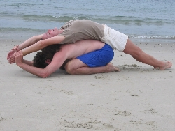
S.M. & T.C. - Photo: J. C.

Fall Schedule
Thursdays, 5:30-6:30
at the C.C. Mellor Edgewood Library / Club
One Pennwood Ave. Pittsburgh, Pennsylvania 15218
Mondays, 5:30-6:30
at the Homewood Library, upstairs Meeting Room
7101 Hamilton Ave. Pittsburgh, Pennsylvania 15208

We'll creatively explore a wide range of positions, inner and outer movement, partner work, and breathing, as well as ideas and thinking / reasoning. But Scott likes, in particular, to explore regenerative and restorative poses meditatively.
- For beginners and experienced practitioners
- $30 for 6 classes (use within 8 weeks); $7 per class

